

25 July 2018

Mr. Jesus Torres
Liquor Purchasing Department
Vallarta Supermarkets

RE: Rancho Escondido Price Increase Notification

Dear Don Chuy,

This is to inform you that due to a continued increase in the cost of the Agave and consequently our importation cost, your Rancho Escondido’s pricing will be adjusted as follows:

Rancho Escondido 12/750ml Your Cost $73.50 per case
($6.13 per bottle)

Suggested retail (everyday) $8.75 (30% Margin)
Suggested Ad Price $7.99 (23% Margin)

Rancho Escondido 6/1.75L Your Cost $90.00 per case
($15.00 per bottle)

Suggested retail (everyday) $19.99 (25% Margin)
Suggested Ad Price $18.99 (21% Margin)

Please contact Roberto Huerta for any additional information or any supplier’s based promotion.

Thank you very much for our continued partnership and we look forward to being of value to you and your business.

With kind regards,
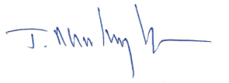

Javier Martinez, President

