

3 June 2020

Mr. Bruce Pack
Director of Grocery Procurement
Vallarta Supermarkets

RE: Tres Estrellas & El Viñador Jerez Price Increase Notification

Dear Bruce,

This is to inform you that due to a price increase from our supplier in Mexico, we are forced to adjust our prices, effective June 30th, for both of our products, Tres Estrellas Jerez and El Viñador Jerez, as follows:

Thank you very much for our continued business and we look forward to being of value to you and your business.

With kind regards,
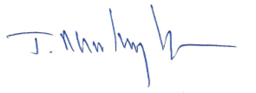

Javier Martinez, President

