

25th July 2018

To all our valued customers:

This is to inform you that due to a continued increase in the cost of the Agave, and effective immediately, 25th of July 2018, Rancho Escondido will have a small price adjustment as follows:

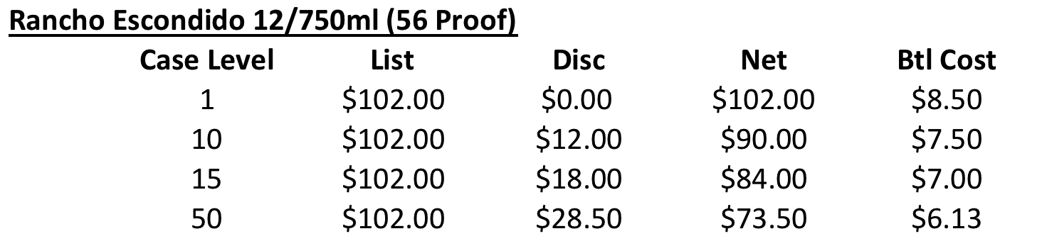

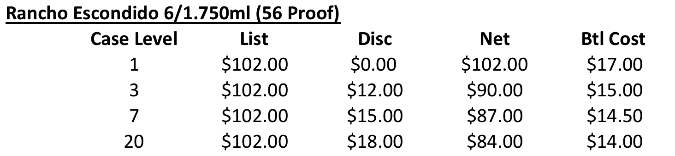

Rancho Escondido has been an outstanding performer due to its excellent quality, competitive price and HUGE brand recognition amongst Mexican consumers. We believe Rancho will continue to be very competitive and do very well. For further details please contact your sales representative.

Thank you very much for our continued partnership and we look forward to being of value to you and your business.

With kind regards,
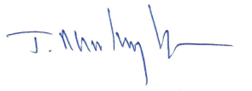
Javier Martinez
President

