

July 20th., 2020

RE: Coronado Rompope Price Increase Notification

Dear Buyer,

This is to inform you that effective 1st September 2020 and due to a price increase from our supplier in San Luis Potosí, Mexico, the price of CORONADO Rompope will be adjusted as follows:

Many ingredients of the original artisanal craft and superior quality of CORONADO’s recipe, particularly sugar cane alcohol (rum), have experienced significant cost increases over the last few months.

Please contact your sales representative for details regarding QD discounts and promotions.

Thank you very much for our continued partnership and we look forward to being of value to you and your business.

With kind regards,
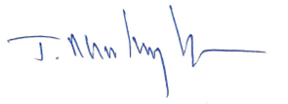

Javier Martinez, President

